**Difference between Arrays.sort and Collections.sort?**  
Arrays.sort works for arrays which can be of primitive data type also. [Collections](https://www.geeksforgeeks.org/collections-in-java-2/).sort() works for objects Collections like [ArrayList](https://www.geeksforgeeks.org/arraylist-in-java/), [LinkedList](http://geeksquiz.com/linked-list-in-java/), etc.

Difference between List and Set?

|  |  |  |
| --- | --- | --- |
| **Nature** | **List** | **Set** |
| Duplicate Objects | Allow duplicates | doesn’t allow duplicates |
| Insertion Order | List is an ordered collection. Maintains order or element | Set is an unordered collection, you get no guarantee on which order element will be stored |
| Null values | Allows mulitple null values | Allows only one null value |
| When to use | 1)If you need to access elements frequently by using the index than List is a way to go. Its implementation e.g. [ArrayList](http://javarevisited.blogspot.com/2011/05/example-of-arraylist-in-java-tutorial.html) provides faster access if you know index.  2)If you want to store elements and want them to maintain an order on which they are inserted into a collection then go for List again, as List is an ordered collection and maintain insertion order. | If you want to create a collection of unique elements and don't want any duplicate than choosing any Set implementation  e.g. HashSet, LinkedHashSet or TreeSet. |

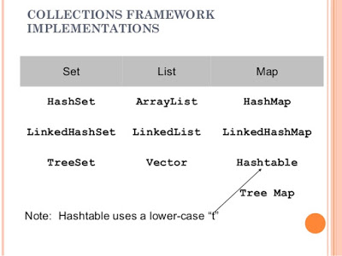

Difference between HashMap and HashSet

|  |  |  |
| --- | --- | --- |
| Nature | HashMap | HashSet |
| Implementation | Map | Set |
| Duplicates |  |  |
|  |  |  |
|  |  |  |
|  |  |  |

Difference between HashMap and HashTable

|  |  |
| --- | --- |
| HashMap | HashTable |
| HashMap is not synchronized.It is not thread safe and can’t be shared between many threads without proper synchronization | HashTable is synchronized. It is thread safe and can be shared with many threads. |
| HashMap allows one null key and multiple null values | Hashtable doesn’t allow any null key or value. |

**Why HashTable doesn’t allow null and HashMap does?**  
To successfully store and retrieve objects from a HashTable, the objects used as keys must implement the hashCode method and the equals method. Since null is not an object, it can’t implement these methods. HashMap is an advanced version and improvement on the Hashtable. HashMap was created later.